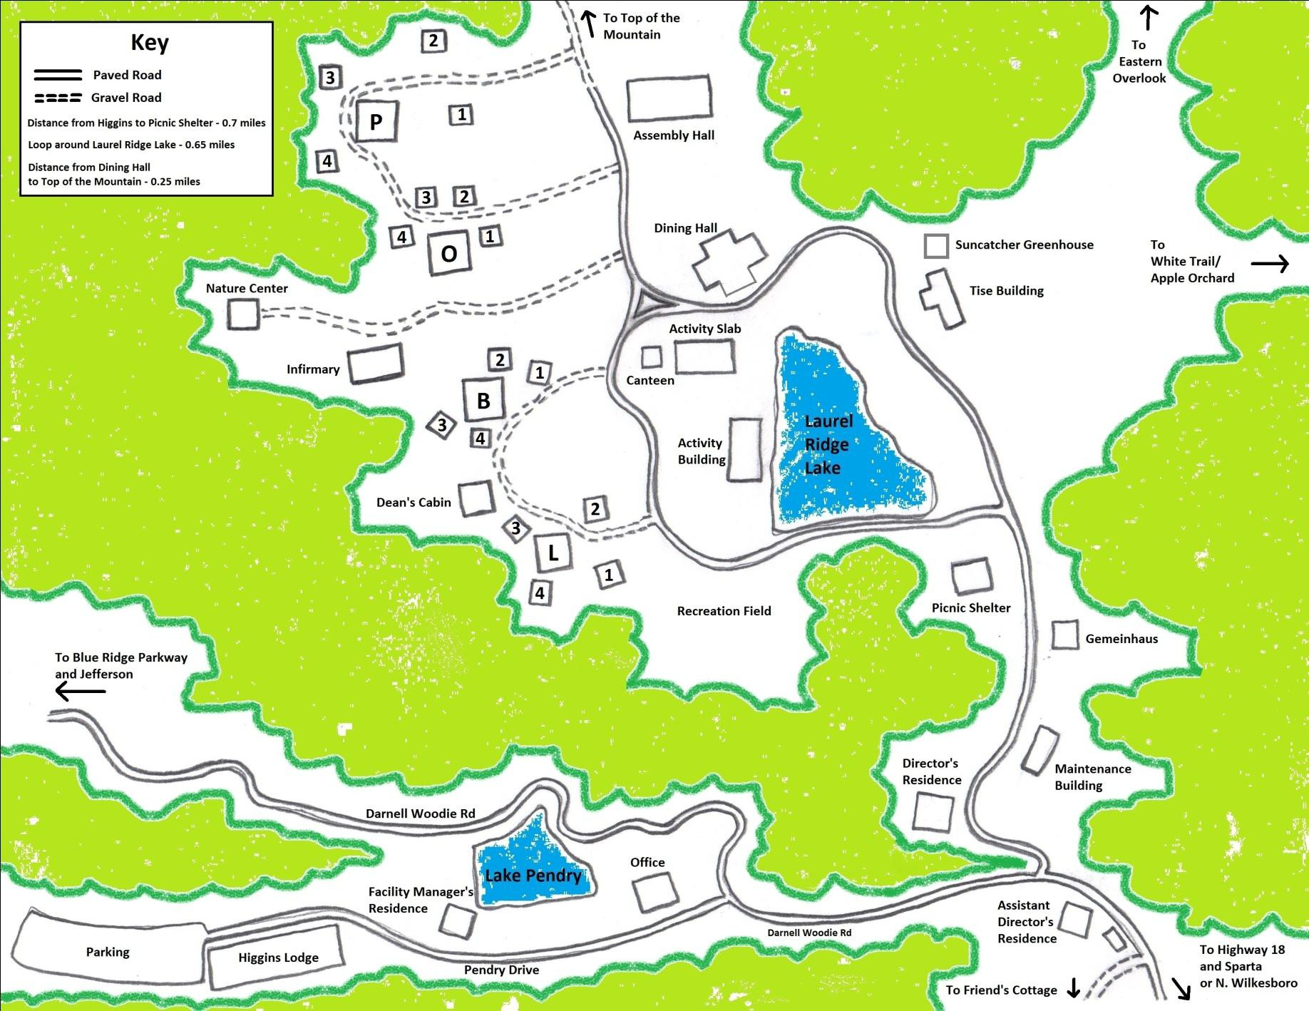
Pines

Oaks

Birches

1
Laurels
Laurel Ridge Property Map
2
4
3

GIC Course

Assistant Director’s
Facility Manager’s

